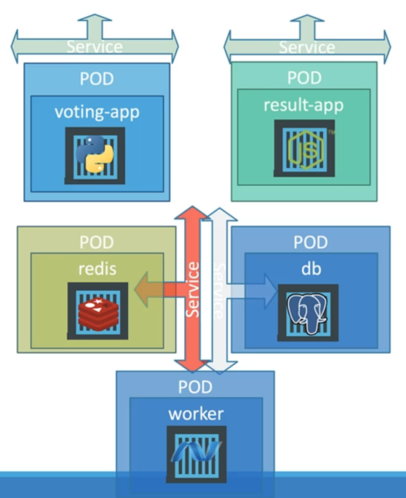 This is what we saw in our last demo in a very simple way. But deploying applications as just pod has its own challenges. Deploying pods doesn’t help us scale our application easily. If we wanted to add more instances of a particular service, and if we wanted to update the application like an image that was used in the application, then your application will have to be taken down while the new pod is created so that may result in the downtime. So, the right approach is to use deployments to deploy an application. Let’s now improvise our setup using the deployments:

We may choose deployments over replica sets as deployments automatically create replica sets as required. And it can help us perform rolling updates and rollbacks and maintain a record or revisions and record the cause of changes. We’ll add more pods if required for the front-end applications like voting-app and result-app.

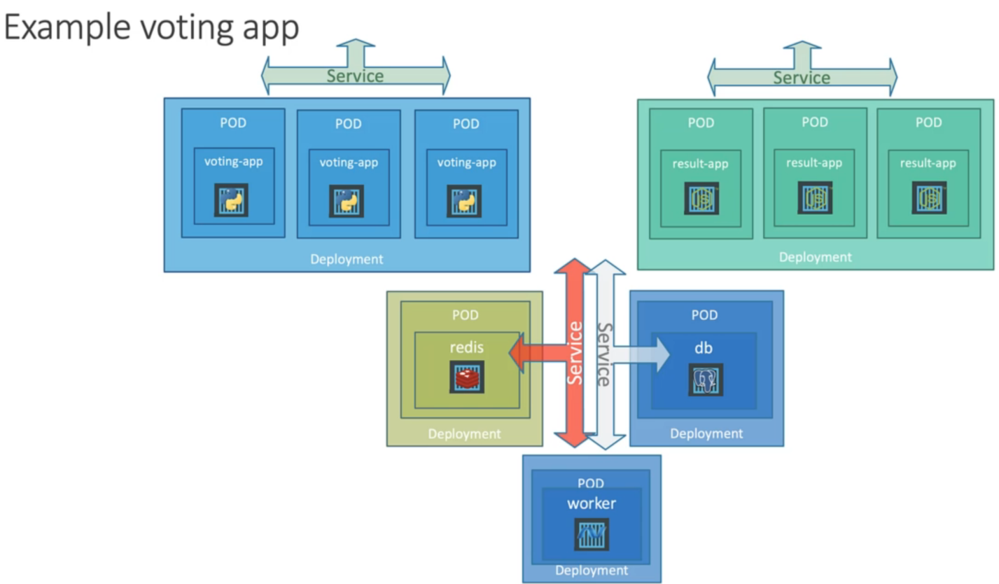

Check the 47-Voting-App folder code first and then run the below commands in sequence:

